**Exercise 4: Creating and Configuring a Maven Project**

**Scenario:** You need to set up a new Maven project for the library management application and add Spring dependencies.

Steps:

1. Create a New Maven Project:

* Create a new Maven project named LibraryManagement.

2. Add Spring Dependencies in pom.xml:

* Include dependencies for Spring Context, Spring AOP, and Spring WebMVC.

3. Configure Maven Plugins:

* Configure the Maven Compiler Plugin for Java version 1.8 in the pom.xml file.

IMPLEMENTATION:

**Step 1: Create a New Maven Project**

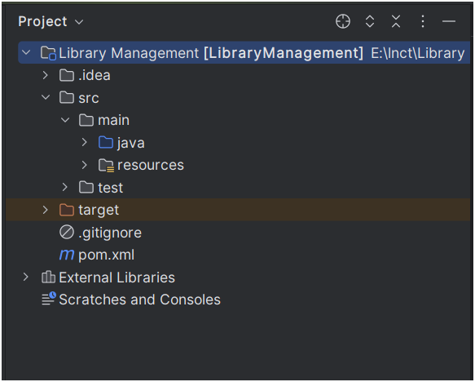

**Step 2: Add Spring Dependencies in pom.xml**

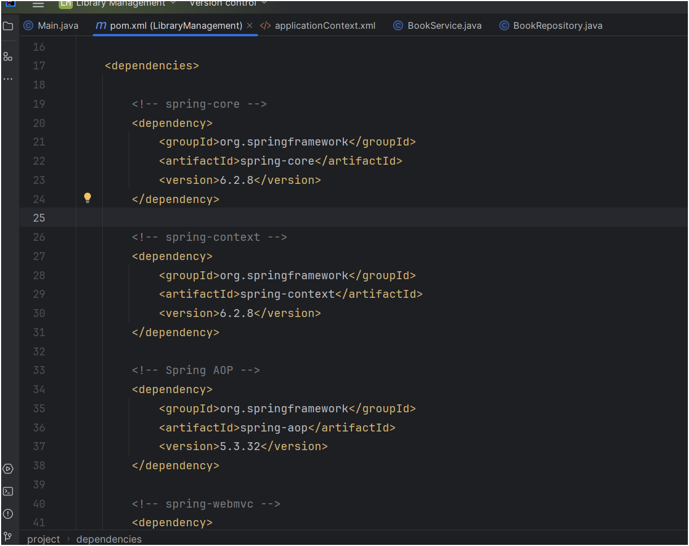

**Step 3: Configure Maven Compiler Plugin**

